CSE370 Database Systems: Lab Assignment 3

Objective | Practice advanced SQL operations and JOIN using multiple tables in MySQL.
Due Date: | 1 Week, submit before next class | Number of Questions: | 10

Scenario:
You are working as a data analyst for a banking corporation that operates multiple branches across different cities. The bank maintains records of customers, their accounts, loans, and branch information. Your task is to write SQL queries using joins to extract information from the interconnected data across multiple tables.

Part 1: Understanding the Data
Find the table schema and sample data here: CSE370 Lab3 Data - BankDB
Follow the instructions given in the document to create the tables and insert data into them.
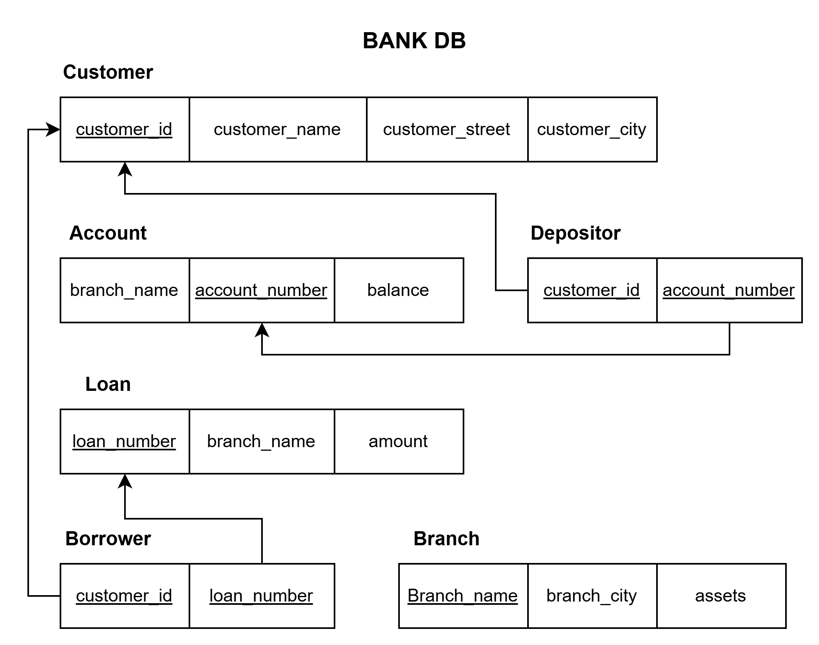
The database schema is shown below for visualizing the relationships between tables.
PKs are shown with underline, and FKs are shown with arrows. [PK: Primary Key, FK: Foreign Key]

Part 2: Questions
IMPORTANT: Provide one single query per question! Your query should not be hard coded, it should provide the logic mentioned in the question.
Write SQL queries to complete the following tasks: [10 * 1 = 10]
Q1. | Find the name and loan number of all customers having a loan at the Downtown branch.
Q2. | Find the name of customers who have taken a loan.
Q3. | Find the name of customers who have not taken a loan.
Q4. | Find all the possible pairs of customers who are from the same city. Show in the format Customer1, Customer2, City.
Q5. | If the bank gives out 4% interest to all accounts, show the total interest across each branch. Print Branch_name, Total_Interest (round up to 2 decimal places)
Q6. | Find account numbers with the highest balances for each city in the database.
Q7. | Show the loan number, loan amount, and name of customers with the top 5 highest loan amounts. The data should be sorted by increasing amounts, then decreasing loan numbers in case of the same loan amount. [Hint for top 5: Check the "limit" keyword in mysql]
Q8. | Find the names of customers with an account and also a loan at the Perryridge branch.
Q9. | Find the total loan amount of all customers having at least 2 loans from the bank. Show in format customer name, total_loan.
Q10. | Find the customer_id and sum of balances of all customers who have more than one account. Display customer_id and total_balance.

Submission Instructions
Make a copy of the submission template in your own Google Drive. For each task in Part 2:
- Write the MySQL command in your submission document.
- Execute the command in XAMPP shell (MySQL command line), take a screenshot showing the command and output, then paste it below the command in your document.
- Repeat for all 10 tasks.
- Download your document as PDF.
- Rename using format: ID_Name_CSE370_Lab_Sec##_Assignment03_Spring26.pdf
Example: 12345678_JohnDoe_CSE370_Lab_Sec12_Assignment03_Spring26.pdf
- Submit via the Google Form in your Discord section channel.

